American Blind Golf Ohio
Host of the 2024 Nations Cup, The Ryder Cup of Blind Golf
“Fore” the Warrior Blind Golf 12th Anniversary Charity Scramble
Pine Valley Golf Club Wadsworth, OH 44281
Team Registration Form

On Friday afternoon, June 14,2024 American Blind Golf will host their 19th Annual Blind Golf Charity Scramble. Registration & hot dogs/burgers starting at 12:30 with shotgun start at 1:45. The event will mark the 12th anniversary supporting Wounded Warriors. Please join us for an opportunity to play 18 holes up close and personal with one of the visually impaired athletes & their coaches or one of our honored Wounded Warriors. Cost is $100 per golfer ($400 a team) and includes: lunch, golf, cart, beverages, prizes, Awards Dinner sponsored by Blue Heron at the end of the day and a day on the links you will never forget! Golfers are to enter in teams of 4 players. Proceeds to benefit the Adaptive Technology Blind Scholarship Fund, Veteran Initiatives & the Wounded Warrior Project. For more information, please call Mark Arnold at (330) 419-1710 or by email americanblindgolf@gmail.com.

Name of Team:_____________________________________________________

Contact Person’s Address:____________________________________________

__________________________________________________________________

Phone/Email:______________________________________________________

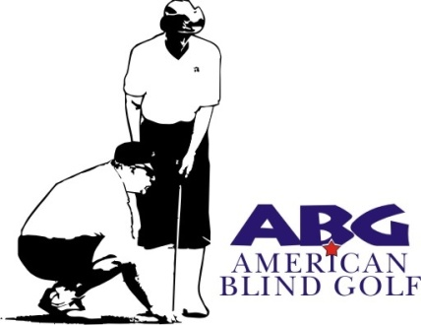

Return to:
American Blind Golf Ohio
C/o Mark Arnold
414 Allen Drive
Wadsworth, OH 44281-2119
Please make checks payable to ABG Ohio
Deadline for Registration June 10, 2022
Tournament Website:
www.OhioBlindGolf.com

