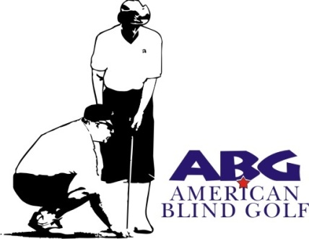

Host of the 2024 Nations Cup
The Ryder Cup of Blind Golf
June 11 through 14, 2024 Pine Valley Golf Club
Wadsworth, Ohio

American Blind Golf is a 501C3 Non-Profit Golfing Organization

Tee Sign Opportunities
Individual, Business or Club/Organization

Practice Green (located in front of the clubhouse) $150
Tee $100

Name:_______________________________________________________________________

Address:_____________________________________________________________________

Phone/Email:_________________________________________________________________

Return to:
Ohio Blind Golf
c/o Mark Arnold
414 Allen Drive
Wadsworth, OH 44281-2119

Please make checks payable to ABG-Ohio
Proceeds to benefit the Adaptive Technology Scholarship Fund
Local Veteran Initiatives & The Wounded Warrior Project

For more information contact Mark Arnold (330) 419-1710 or americanblindgolf@gmail.com. The official tournament website is: www.OhioBlindGolf.com.

