American Blind Golf Ohio
2019 “Fore” the Warrior Blind Golf Charity Scramble
Hawk’s Nest Golf Course Creston, OH

Team Registration Form
On Friday afternoon, June 28th, American Blind Golf will host their 8th Annual “Fore” the Warrior Blind Golf Charity Scramble. Please join us for an opportunity to play 18 holes up close and personal with these unique athletes & their coaches. Teams may also play with one of our honored Wounded Warriors. Cost is $100 per golfer ($400 a team) and includes: hot dogs/burgers prior to tee off, golf, cart, beverages, prizes, barbeque Dinner sponsored by American Legion #170 at the end of the day and a day on the links you will never forget! Golfers are to enter in teams of 4 players. Proceeds to benefit the Adaptive Technology Blind Scholarship Fund & the Wounded Warrior Project. For more information please call Mark Arnold at (330) 419-1710 or Roger Cline at (330) 835-7239. Enter today, only 22 teams available! Registration/lunch at 11:30 with shotgun start at approximately 1:15.

Name of Team:_____________________________________________________

Contact Person’s Address:____________________________________________

__________________________________________________________________

Phone/Email:______________________________________________________

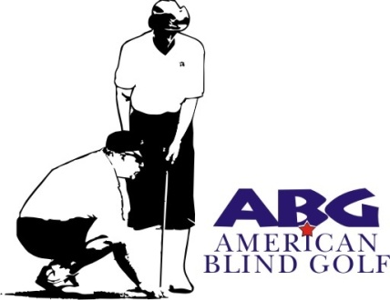

Return to:
American Blind Golf Ohio
C/o Mark Arnold
414 Allen Drive
Wadsworth, OH 44281-2119
Please make checks payable to ABG Ohio
Deadline for Registration June 14, 2019

