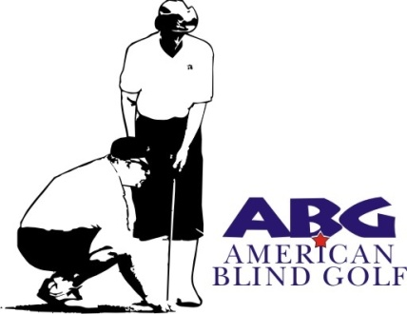

2019 National Match-Play Championships of Blind Golf
June 25 through 28, 2019 Hawk’s Nest Golf Course
Creston, Ohio

American Blind Golf is a 501C3 Non-Profit Golfing Organization

Tee Sign Opportunity

Individual, Business or Club/Organization
Cost $100

Name:________________________________________________

Address:______________________________________________

Phone/Email:__________________________________________

Return to:
Mark Arnold
414 Allen Drive
Wadsworth, OH 44281-2119

Please make checks payable to American Blind Golf Ohio
Return no later than June 14, 2019
Proceeds to benefit the Adaptive Technology Scholarship Fund
The Foundation Fighting Blindness & the Wounded Warrior Project

